|  |
| --- |
| **Options for the Accommodation at Adria Ankaran Hotel and Resort** |

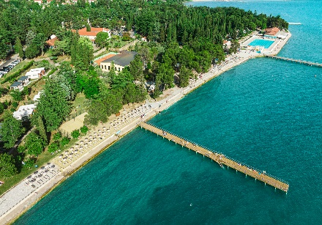 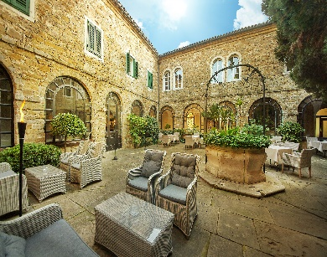 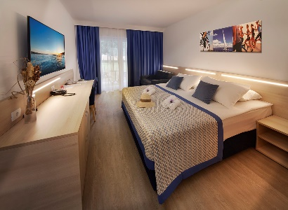

**Minimum stay 1 or 2 nights**

**VILLAS** <https://www.adria-ankaran.si/en/accommodations/villas/>,

**HOTEL** https://www.adria-ankaran.si/en/accommodations/hotel-convent/

**OLIVE SUITES** <https://www.adria-ankaran.si/en/accommodations/olive-suites/>

|  |  |  |  |
| --- | --- | --- | --- |
| **Bed and breakfast per person/per day** | **Villas 4\*** | **Hotel 4\*** | **Olive Suites 4\*** |
| Double room-Single use | 130,00 | 134,00 | 140,00 |
| Double room | 87,00 | 89,00 | 95,00 |
| Doplačilo za večerjo po osebi/dan | 25,00 | 25,00 | 25,00 |

**Minimum stay 3 nights**

|  |  |  |  |
| --- | --- | --- | --- |
| **Halfboard per person/day** | **Villas 4\*** | **Hotel 4\*** | **Olive Suites 4\*** |
| Double room-Single use | 119,00 | 122,00 | 134,00 |
| Double room | 81,00 | 83,00 | 90,00 |

**Price includes:**

* Accommodation in the selected 4\* facility per person/day.
* Breakfast in the Adria resort restaurant.
* Wi-Fi in the room and common areas.
* Access to the indoor pool complex.

**Additional charges:**

* Tourist tax per person/day: €2.50.
* Registration fee: €2.50 per person/stay.
* Parking: €12.00 per stay.

**Minimum stay 3 nights**

**APPARTMENTS** <https://www.adria-ankaran.si/en/accommodations/adria-apartments/>,

**MOBILE HOUSES** hhttps://[www.adria-ankaran.si/en/premium-mobile-homes/](http://www.adria-ankaran.si/en/premium-mobile-homes/" \t "_blank),

**CAMPSITE** <https://www.adria-ankaran.si/en/camping-adria-ankaran/>

|  |  |  |
| --- | --- | --- |
| **Rental per unit/day** | **Up to 6 guests** | **Up to 4 gustes** |
| **Mobile house Premium** | **207,00** | **171,00** |
| **Apartment Adria** |  | **177,00** |
|  |  |  |

|  |  |  |
| --- | --- | --- |
| **Rental with half board per person/day. Min. 2 persons.** | **Up to 6 guests** | **Up to 4 gustes** |
| **Mobile house Premium** | **100,00** | **100,00** |
| **Apartment Adria** |  | **100,00** |

**Price includes:**

* Accommodation in the selected unit per day.
* Wi-Fi in the room and common areas.
* Access to the indoor pool complex.

**Mandatory surcharges:**

* Tourist tax per person/day: €2.50.
* Registration fee: €2.50 per person/stay.
* Parking: €12.00 per stay.
* Final cleaning: €50.00.

**TRAVELS**

Ankraan is a small town on the border btw Italy and Slovenia

Closest international airports are.

**TRIESTE Airport, Italy** <https://triesteairport.it/en/airport/>

**VENICE Airport, Italy** <https://www.veneziaairport.it/en/>

**LJUBLJANA Airpot** <https://www.lju-airport.si/sl/>

**ZAGREB Airport** <https://www.zagreb-airport.hr/>

To get from any of the airports take the **GO OPTI shuttle van** to Ankaran:

<https://www.goopti.com/en/>

**Public bus and train transport is also available.**